# **Quenching Tank Temperature Monitoring System User Manual/Standard Operating Procedure to give the OFFSET**

**Step – 1:**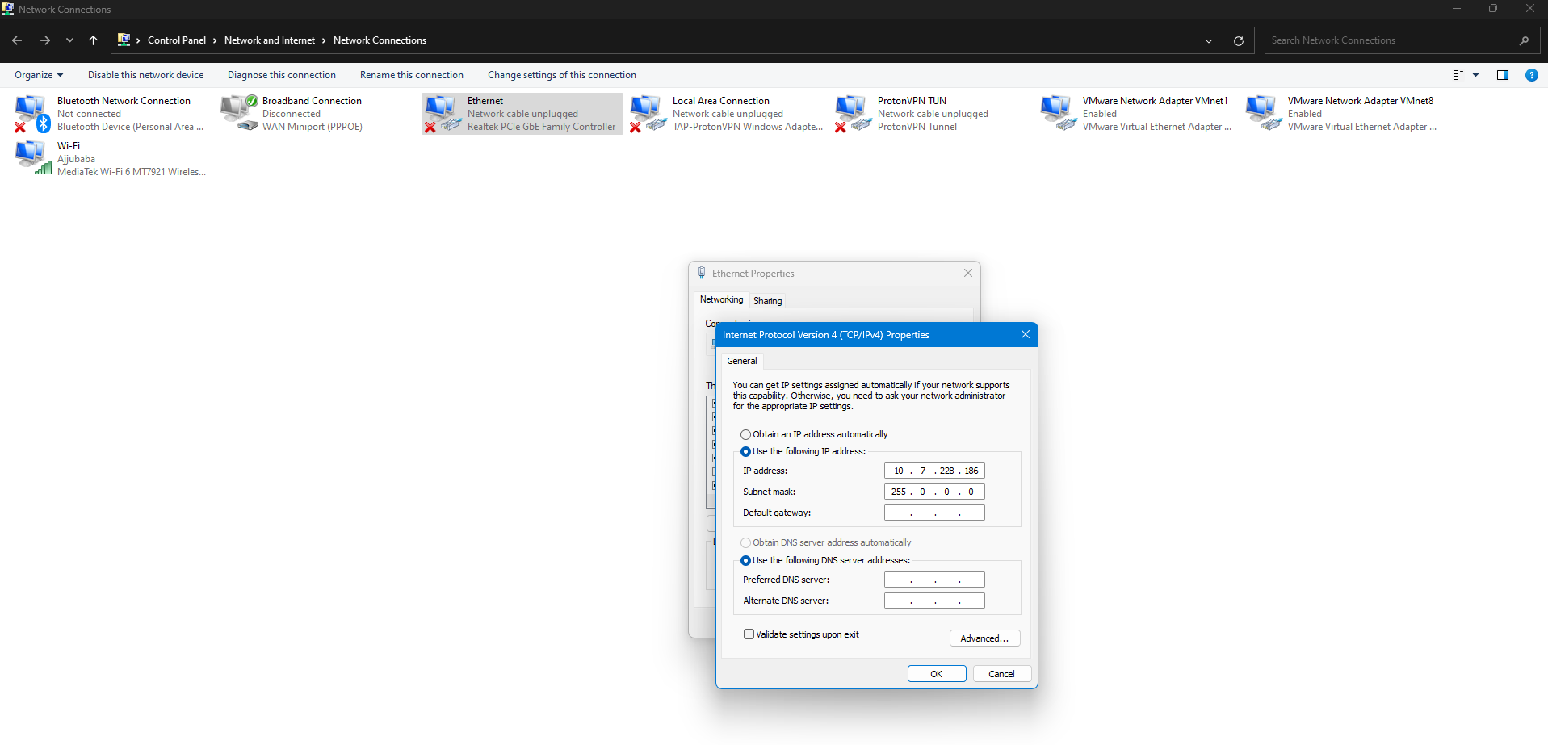Configure the MOXA Ethernet Converter and the host PC to the same network.

**Step – 2:** The software will prompt to configure the COM port for the first time.

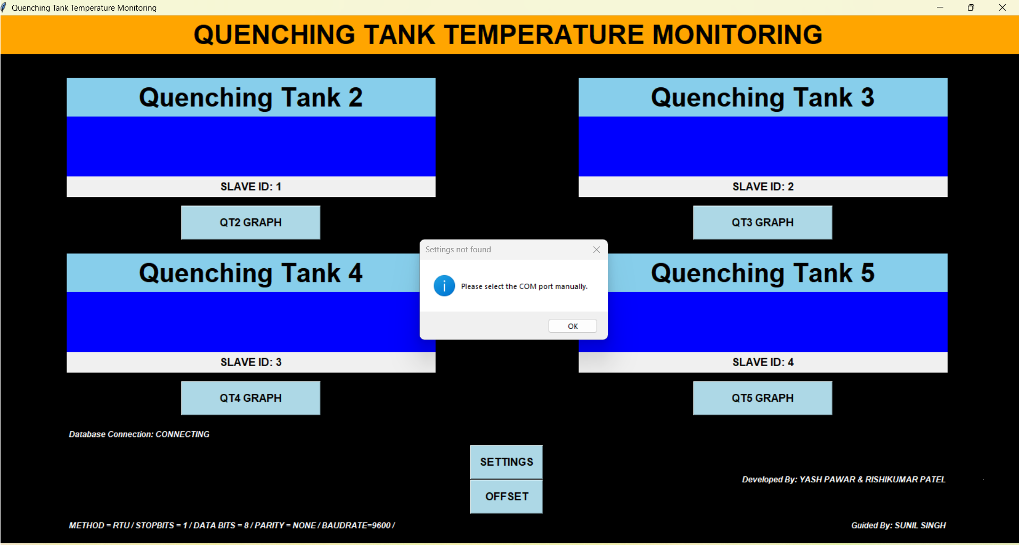

**Step – 3:** Configuring the COM Port will require admin password.

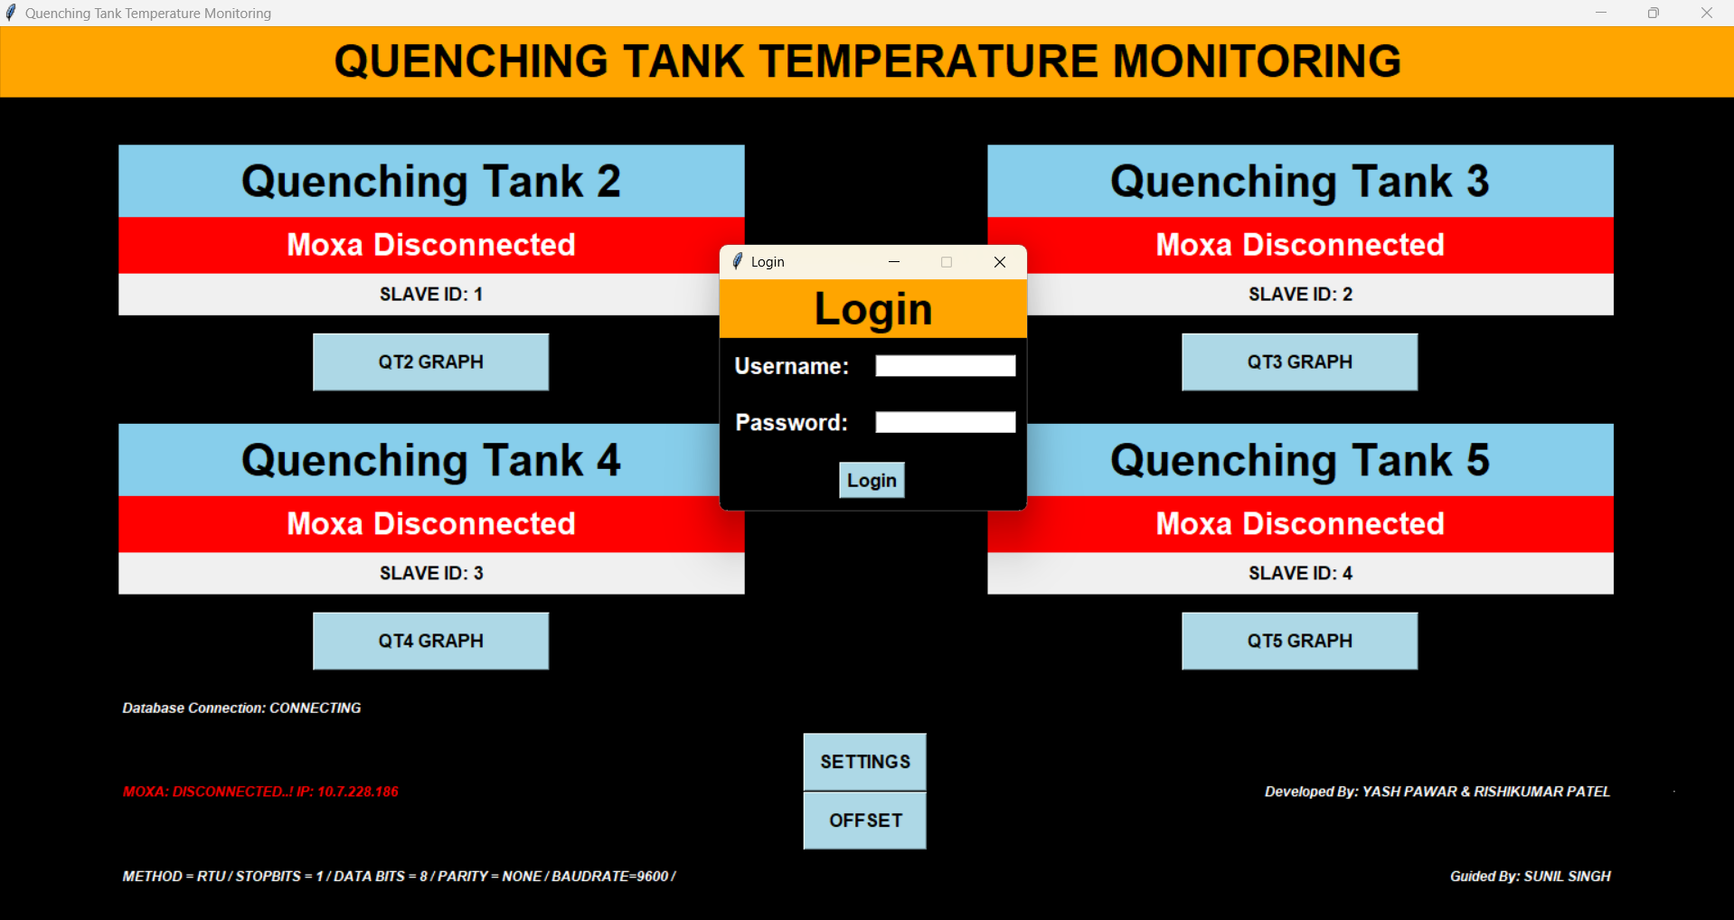

**TROUBLESHOOTING:**

**Error:** Invalid Username or Password

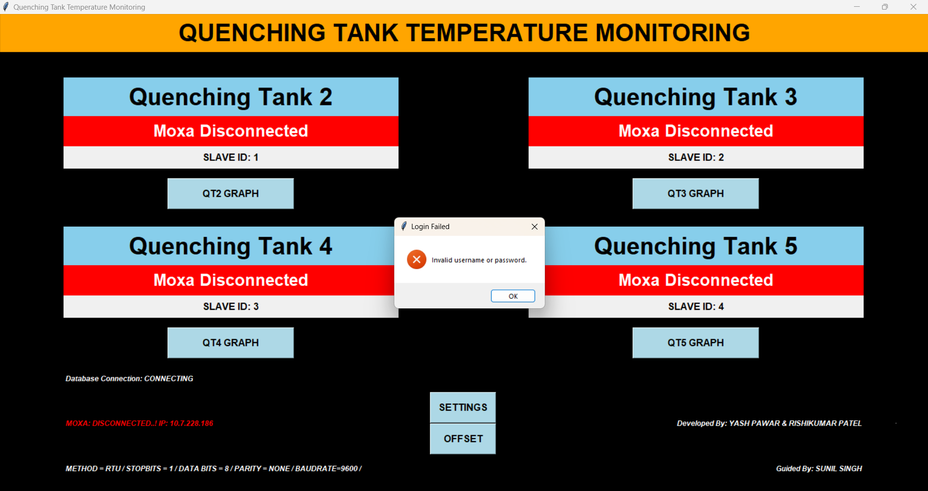

**Solution:** Give the proper Username or Password as per the accessibility

**Step – 4:** If both the Username and the Password is right the message box will be displayed

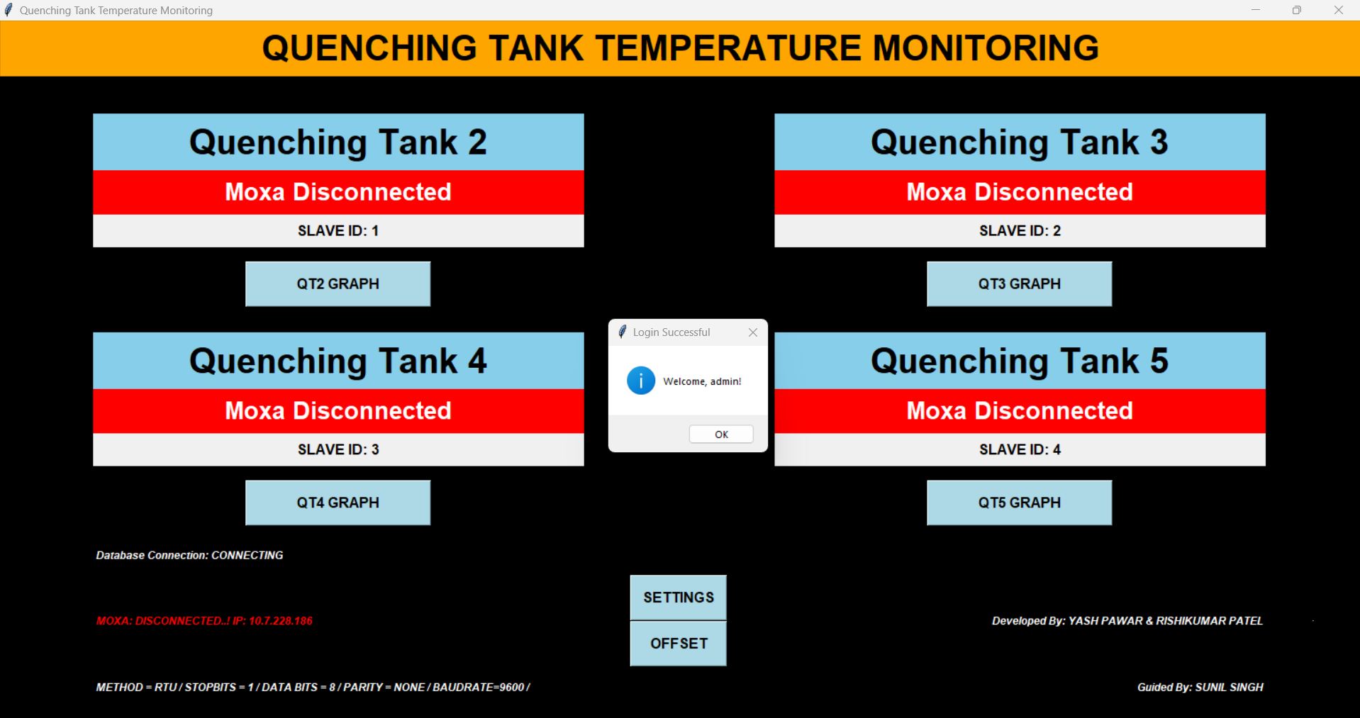

**Step – 5:**  By clicking the ‘ok’ Button the new window open for the Selection of the Quenchtank and then click on the ‘Select’ button

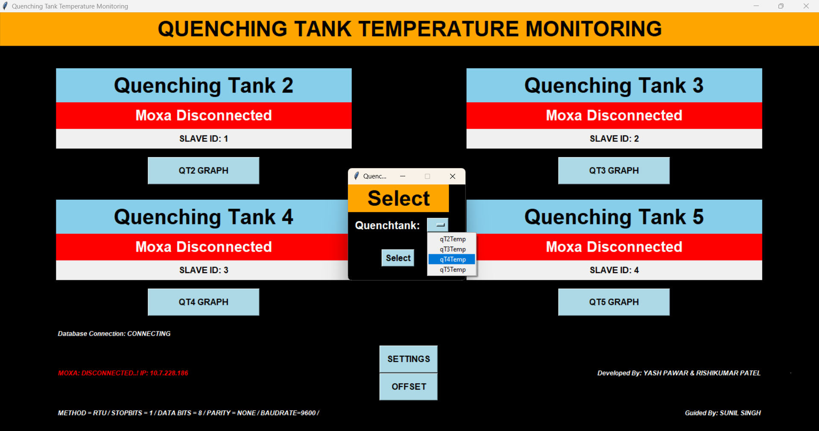

**Step – 6:** The offset window will show the data of the temperature of the Quenchtank selected now by clicking on the ‘INCREMENT’ button data will increase by 0.1 on every click and decrease by 0.1 by every click on the ‘DECREMENT’ button.

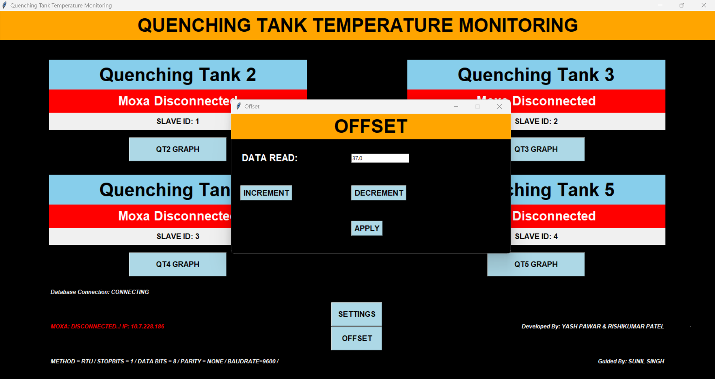

**Step – 7:** After the changes on clicking the ’APPLY’ Button you will receive the message box like this

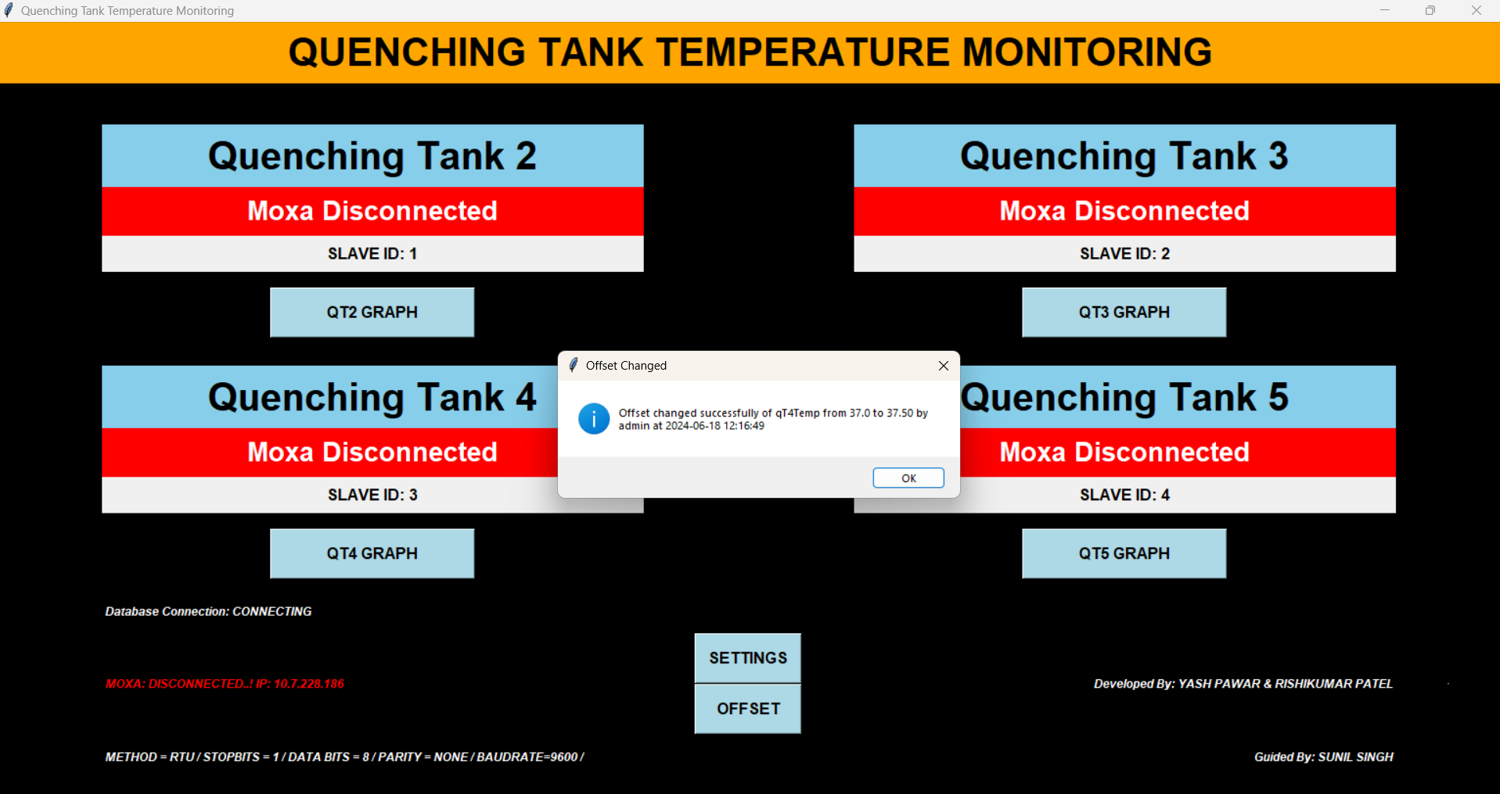

# **Quenching Tank Temperature Monitoring System Developer Guidelines**

1. **Change the data from the dummy data to the SQL data**

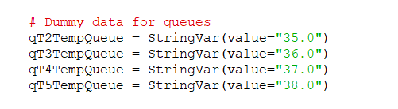

1. **The data can be stored in the SQL database for the future Reference**

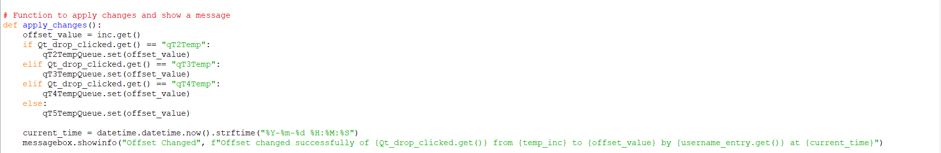

1. **To give the access to the different users through the SQL or Manually**

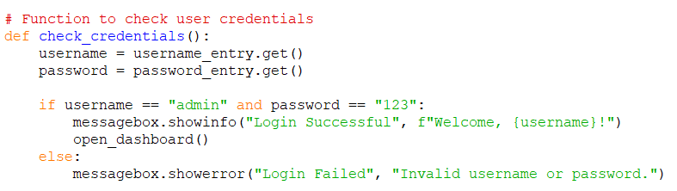

**FUTURE SCOPE:**

1. Storing the Offset changes in the SQL database.
2. Giving access to only some users to do the changes.
3. Storing the database connection string in an encrypted manner.
4. Storing the settings password in an encrypted manner.